ASSIGNMENT-11.1

HT.NO:2303A51726

TaskDescription#1–StackImplementation
Task:UseAItogenerateaStackclasswithpush,pop,peek,andis_empty methods.
SampleInputCode:
classStack:
pass
ExpectedOutput:
- Afunctionalstackimplementationwithallrequiredmethodsand docstrings.

CODE:
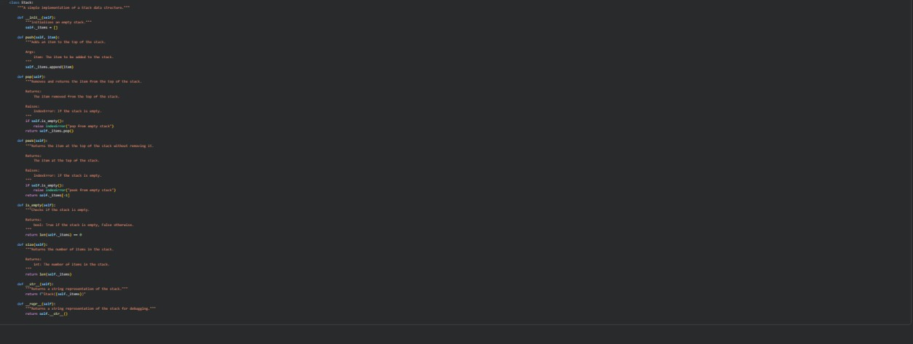

TaskDescription#2–QueueImplementation
Task:UseAItoimplementaQueueusingPythonlists. Sample Input Code:
classQueue:
pass
ExpectedOutput:
- FIFO-basedqueueclasswithenqueue,dequeue,peek,andsize Methods

CODE:
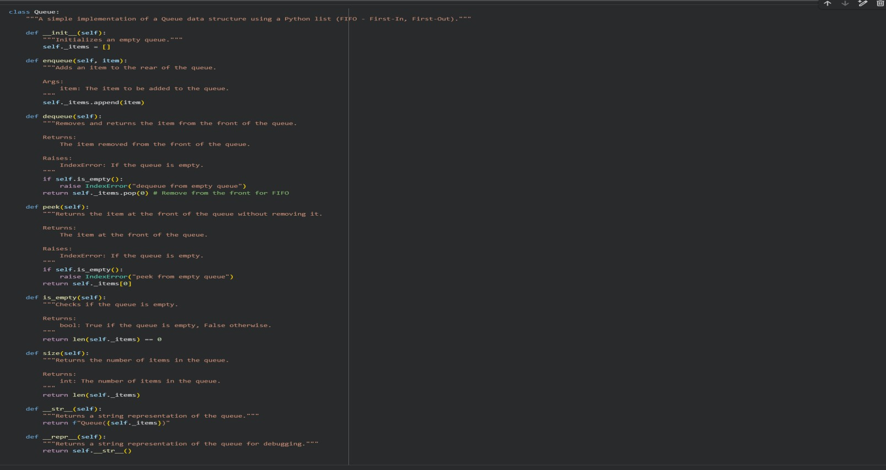

TaskDescription#3–LinkedList
Task:UseAItogenerateaSinglyLinkedListwithinsertanddisplay methods.
SampleInputCode:
classNode:
pass
classLinkedList:
pass
ExpectedOutput:
- Aworkinglinkedlistimplementationwithclearmethod Documentation

CODE:

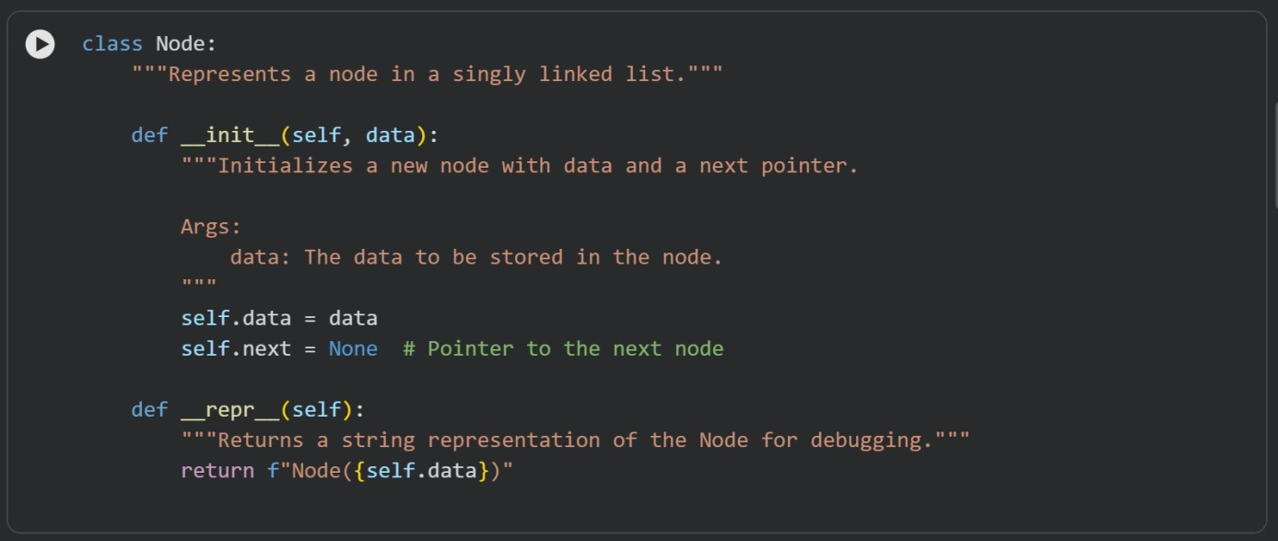
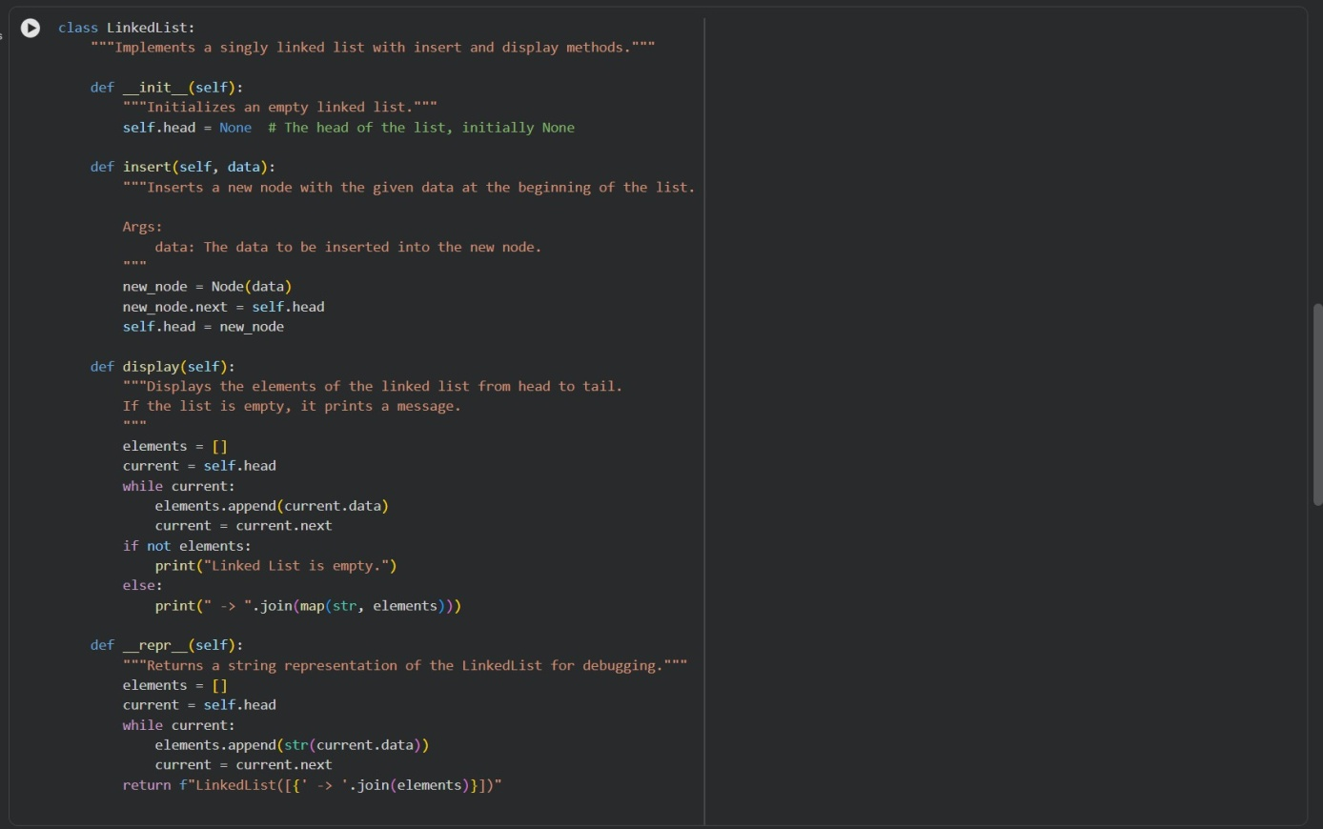
OUTPUT:

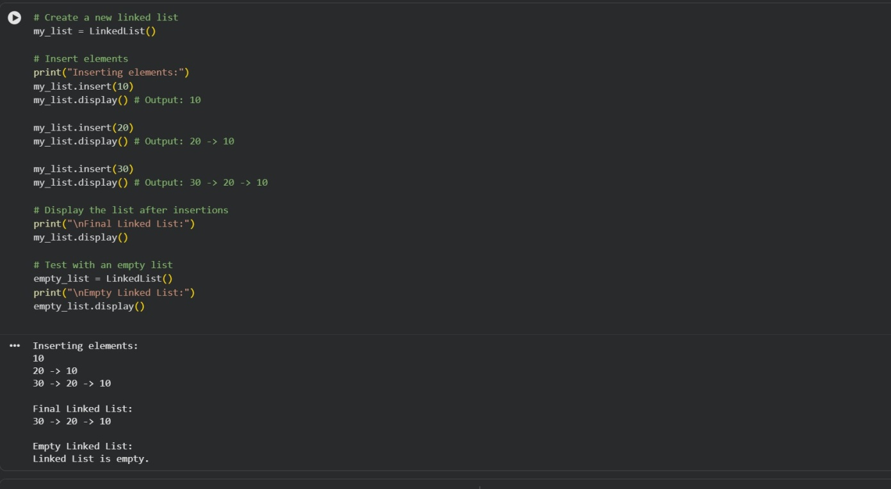

TaskDescription#4–BinarySearchTree(BST)
Task:UseAItocreateaBSTwithinsertandin-ordertraversalmethods. Sample Input Code:
classBST:
pass
ExpectedOutput:
- BSTimplementationwithrecursiveinsertandtraversalmethods.

CODE:
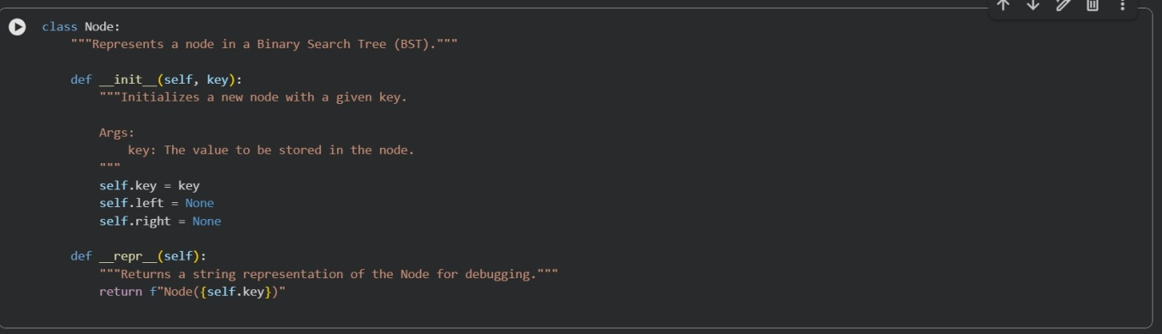

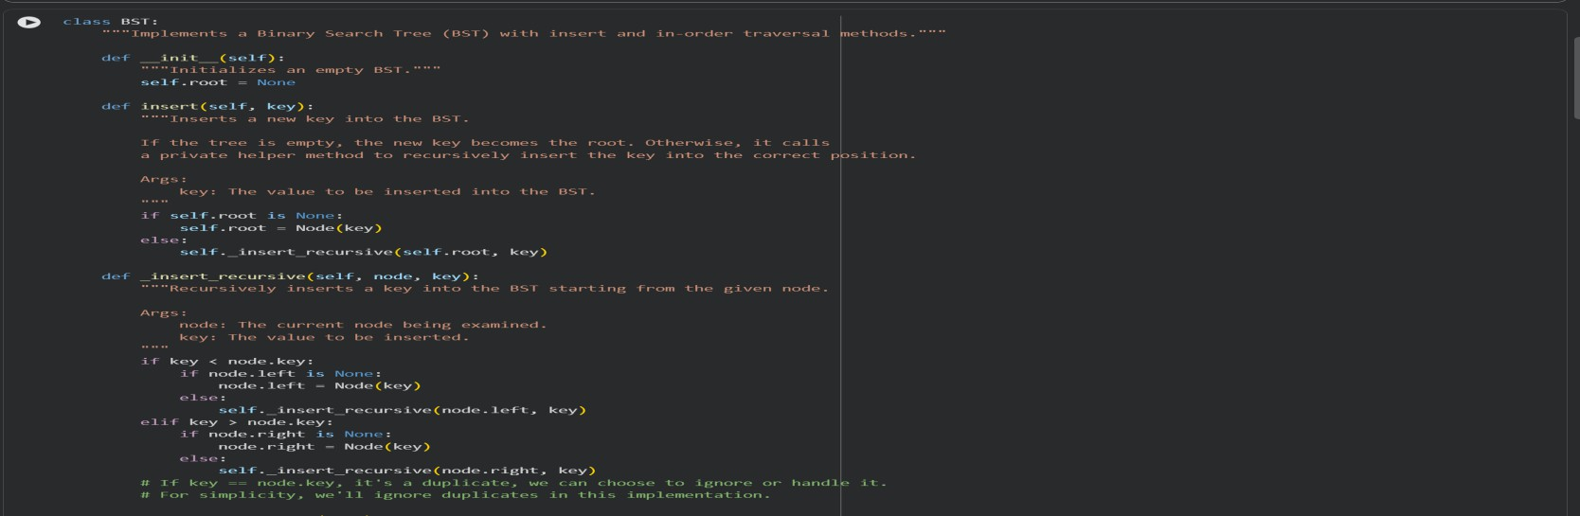
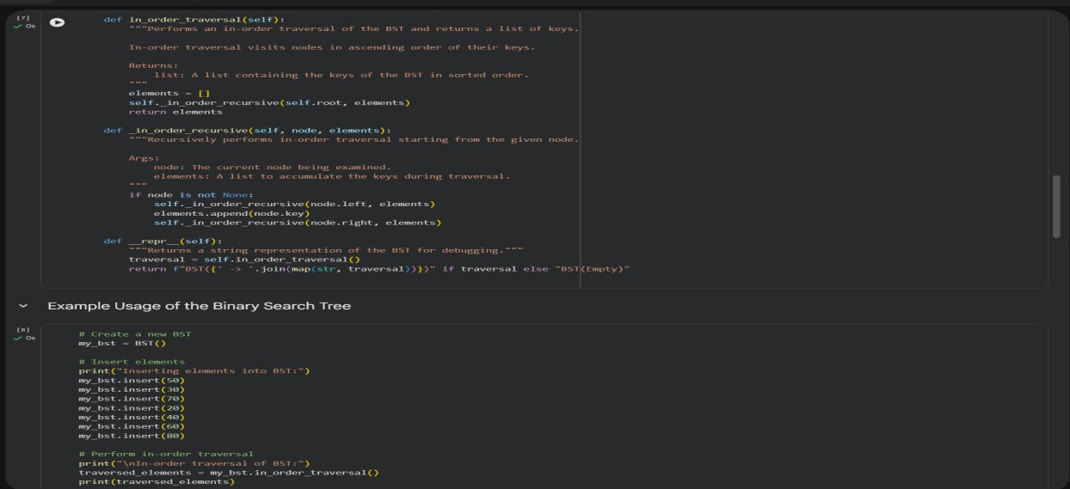

OUTPUT:
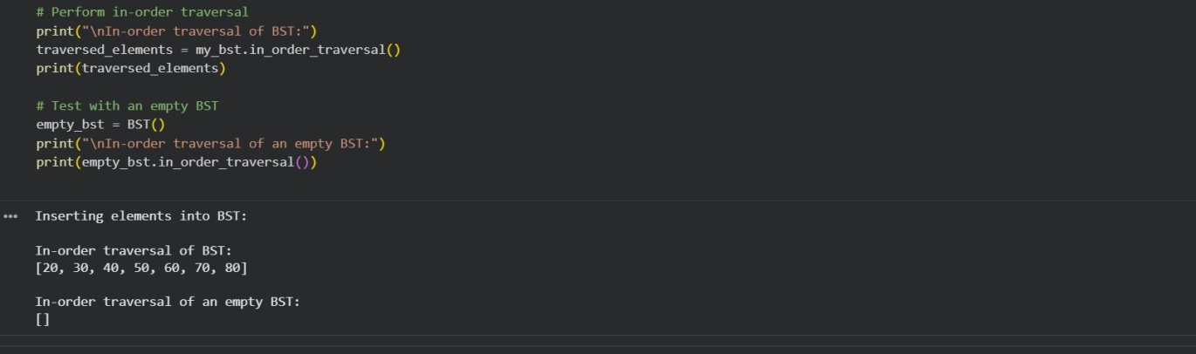

TaskDescription#5–HashTable
Task:UseAItoimplementahashtablewithbasicinsert,search,and delete methods.
SampleInputCode:

classHashTable:
pass
ExpectedOutput:
- Collisionhandlingusingchaining,withwell-commentedmethods.
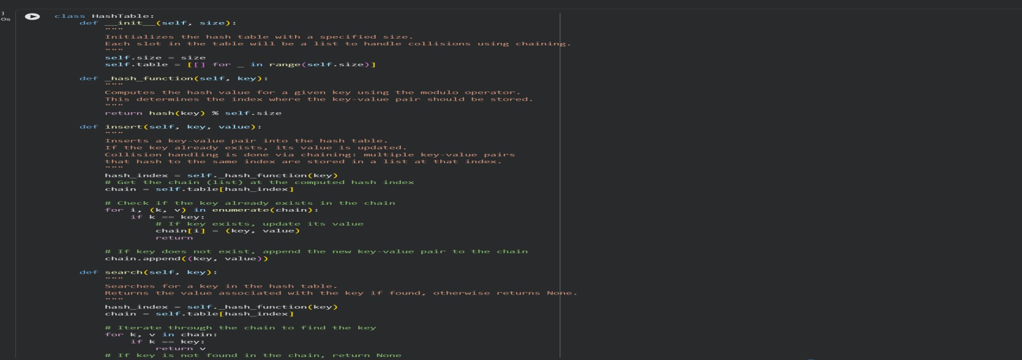
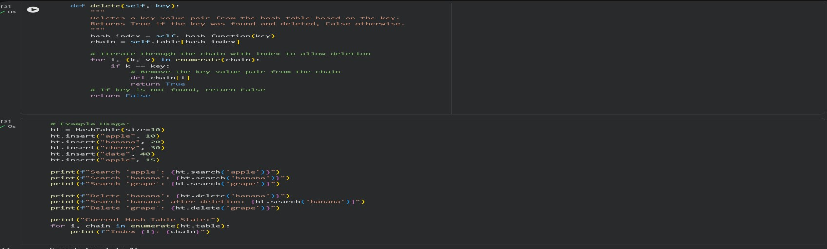

OUTPUT:
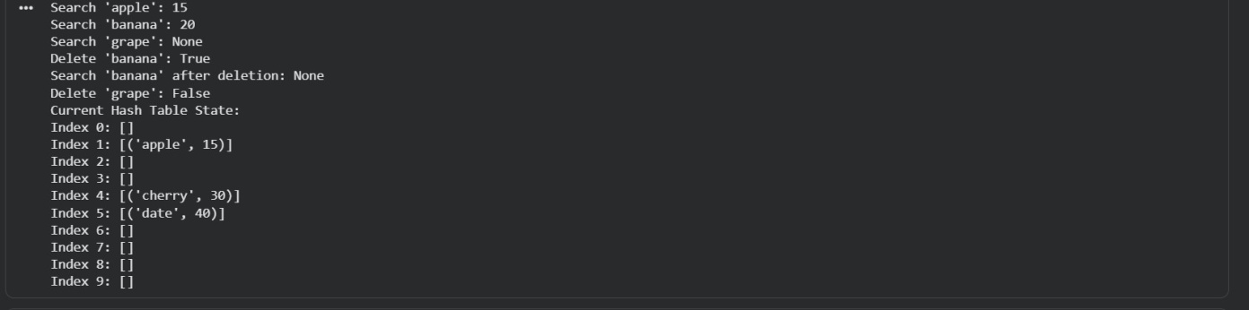

TaskDescription#6–GraphRepresentation
Task:UseAItoimplementagraphusinganadjacencylist.

SampleInputCode:
classGraph:
pass
ExpectedOutput:
- Graphwithmethodstoaddvertices,addedges,anddisplay Connections

CODE:
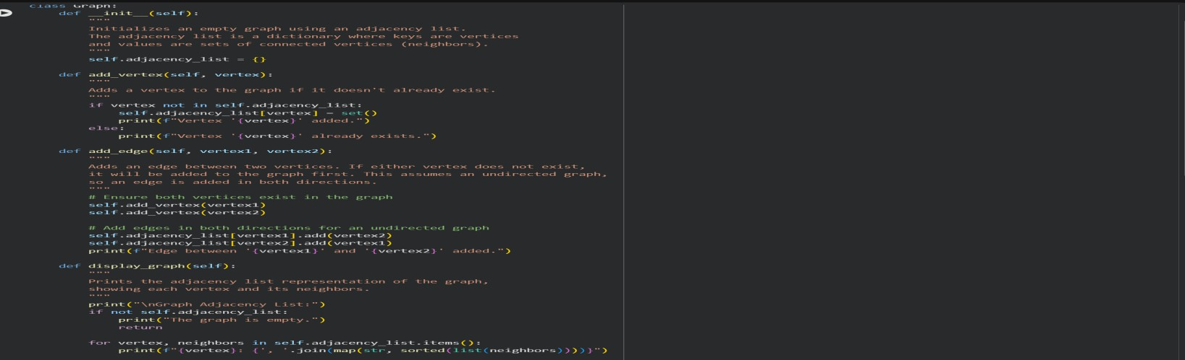
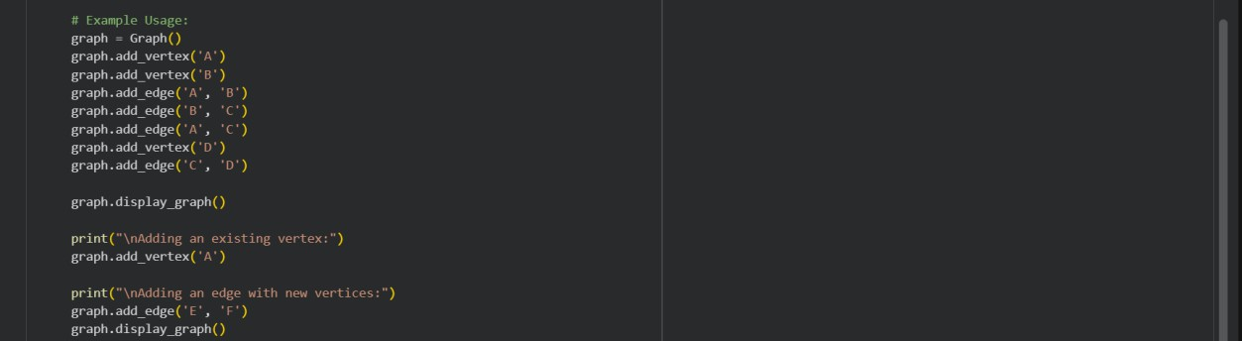

OUTPUT:
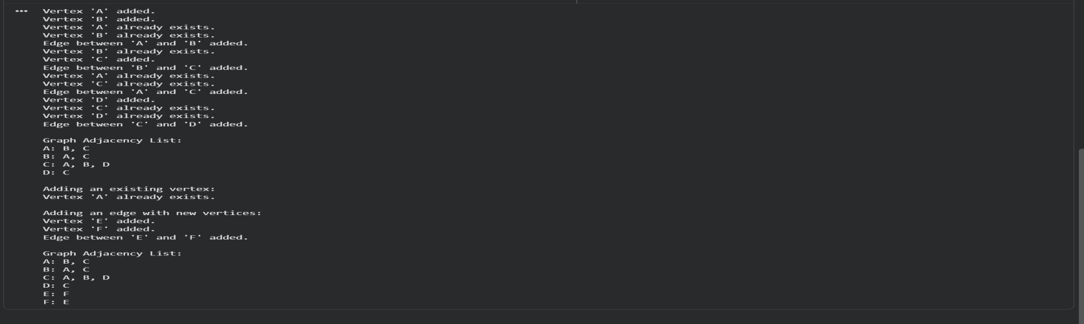

TaskDescription#7–PriorityQueue
Task:UseAItoimplementapriorityqueueusingPython’sheapq module.
SampleInputCode:
classPriorityQueue:
pass
ExpectedOutput:
- Implementationwithenqueue(priority),dequeue(highestpriority), and display methods.

CODE:
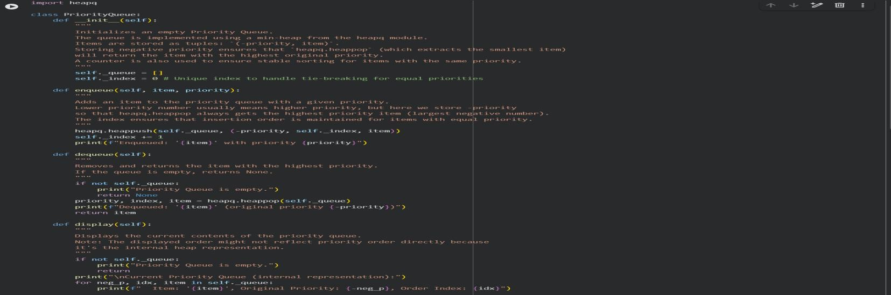
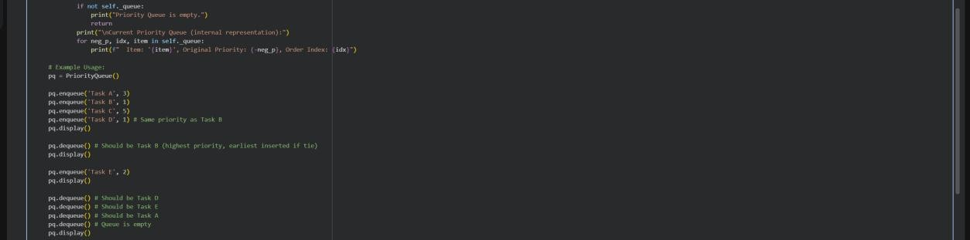

OUTPUT:
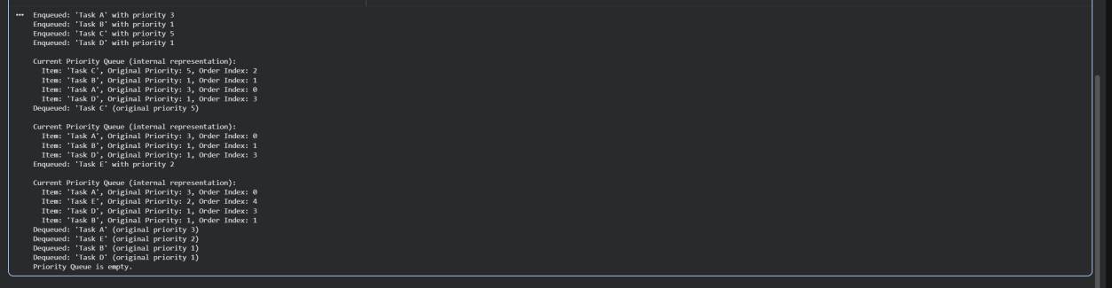
TaskDescription#8–Deque
Task:UseAItoimplementadouble-endedqueueusing collections.deque.
SampleInputCode:
classDequeDS:
pass
ExpectedOutput:
- Insertandremovefrombothendswithdocstrings.

CODE:

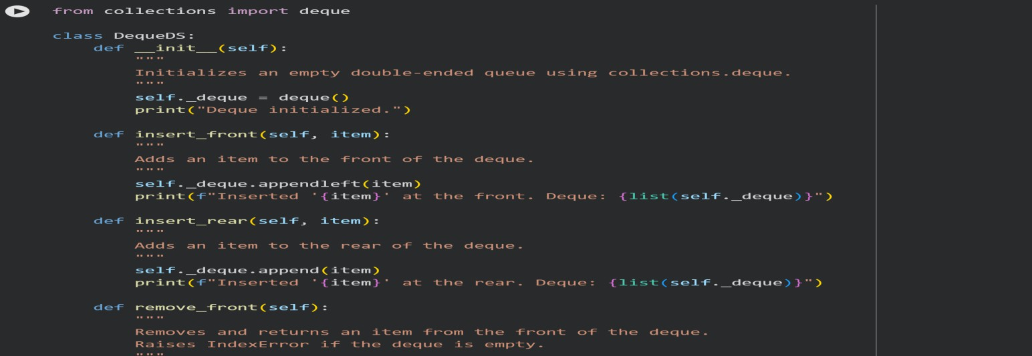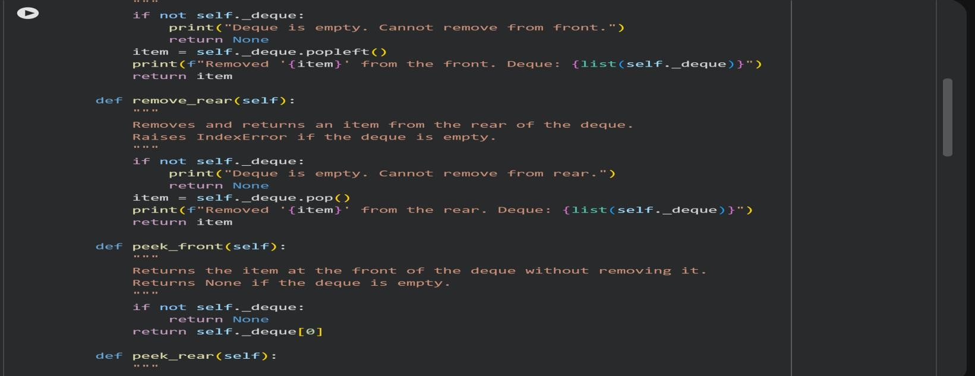
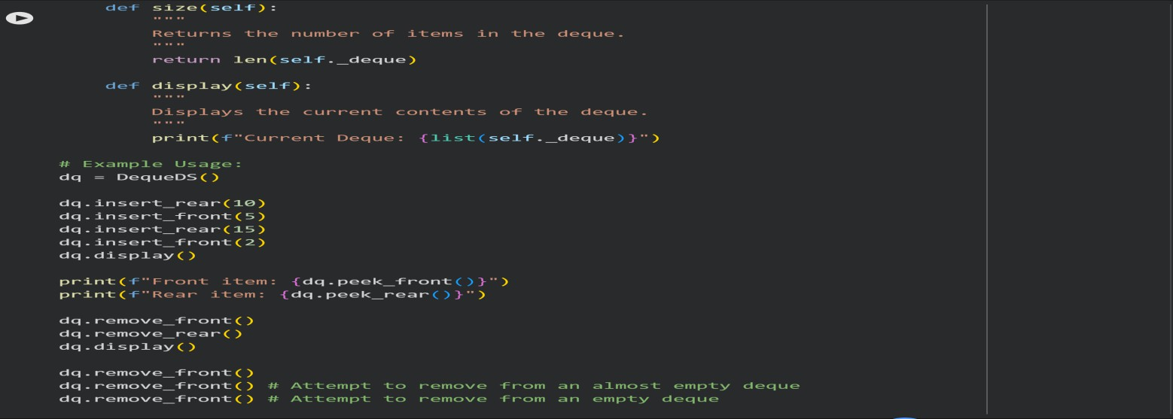

OUTPUT:
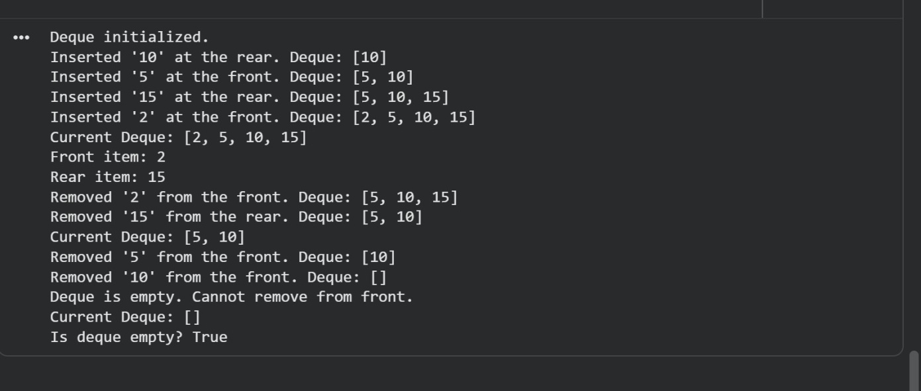
TaskDescription#9Real-TimeApplicationChallenge–Choosethe Right Data Structure
Scenario:
YourcollegewantstodevelopaCampusResourceManagementSystem that handles:
- StudentAttendanceTracking–Dailylogofstudents entering/exiting the campus.
- EventRegistrationSystem–Manageparticipantsineventswith quick search and removal.
- LibraryBookBorrowing–Keeptrackofavailablebooksandtheir due dates.
- BusSchedulingSystem–Maintainbusroutesandstop connections.
- CafeteriaOrderQueue–Servestudentsintheordertheyarrive. Student Task:
  - Foreachfeature,selectthemostappropriatedatastructurefrom the list below:
- Stack
- Queue
- PriorityQueue

- LinkedList
- BinarySearchTree(BST)
- Graph
- Hash Table
- Deque
  - Justifyyourchoicein2–3sentencesper feature.
  - ImplementoneselectedfeatureasaworkingPythonprogramwith AI-assisted code generation.
ExpectedOutput:
  - Atablemappingfeature→chosendatastructure→justification.
  - AfunctionalPythonprogramimplementingthechosenfeature with comments and docstrings

CODE:
DataStructureTable

Featur e | Chosen Data Structure | Justification
Stude nt Atten dance Tracki ng | Hash Table | A Hash Table is ideal for student attendance tracking because it allowsforveryefficientO(1)averagetimecomplexityforadding, removing, and looking up student records by ID. This ensures  quickaccesstoindividualstudentattendancedata,whichis crucial for real-time verification.
Event Regist ration Syste m | Hash Table(for  registrants) andQueue( for waiting list) | A Hash Table can efficiently manage registered participants, offeringquicklookupsandmodificationsbyregistrantID.For  managingawaitinglistorcancellationswhereorderofarrival matters, a Queue would be suitable to process requests on a first-come, first-served basis.
Librar y  Book | Hash Table | A Hash Table is well-suited for tracking books and borrowers, allowingforfastsearchesbyISBNoruserID.Thisenablesquick

Featur e | Chosen Data Structure | Justification
Borro wing |  | retrievalofbookstatus(available/borrowed)andborrower information, essential for a dynamic library system.
Bus  Sched uling Syste m | Graph | AGraphisthemostappropriatedatastructureforabus  schedulingsystemasitcanrepresentroutesasedgesandstops asnodes.Thisstructureinherentlysupportscomplexoperations like finding optimal paths, calculating travel times, and  identifyingconnectionsbetweenstops.
Cafete ria Order Queu e | Queue | A Queue perfectlymodelsafirst-come, first-served (FIFO)order processingsystem,ensuringthatordersarehandledintheexact sequence they are received. This guarantees fairness and  accurateprocessingofcafeteriaorders.
\
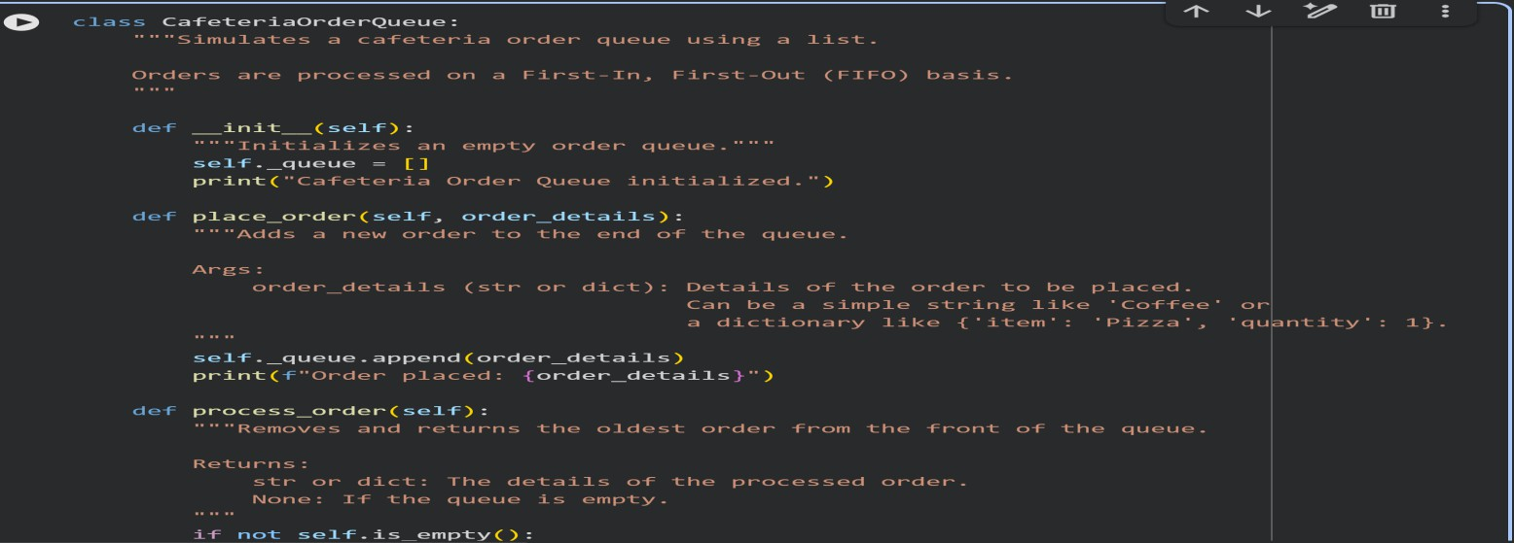

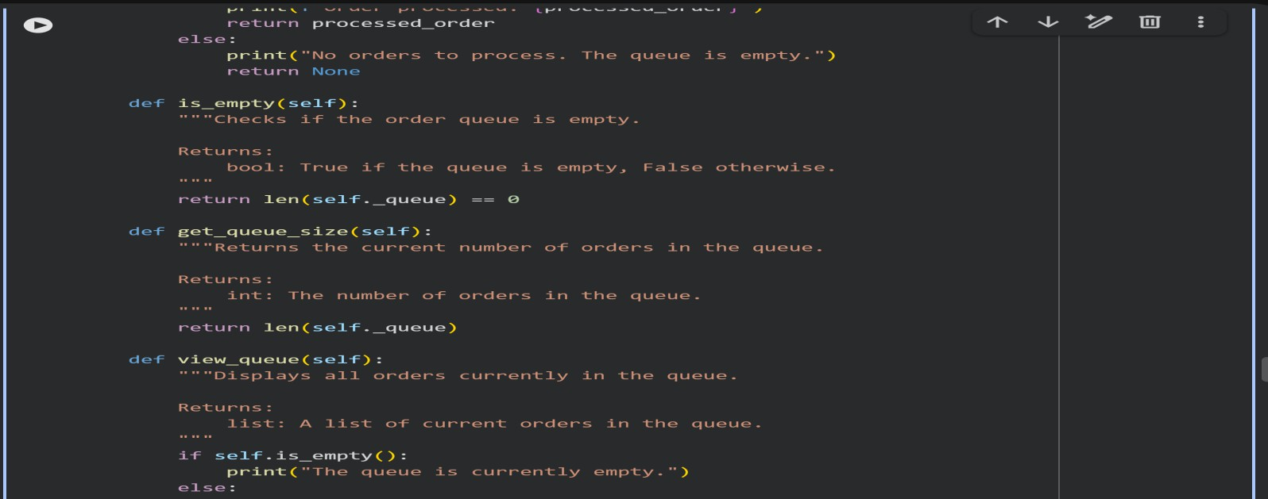
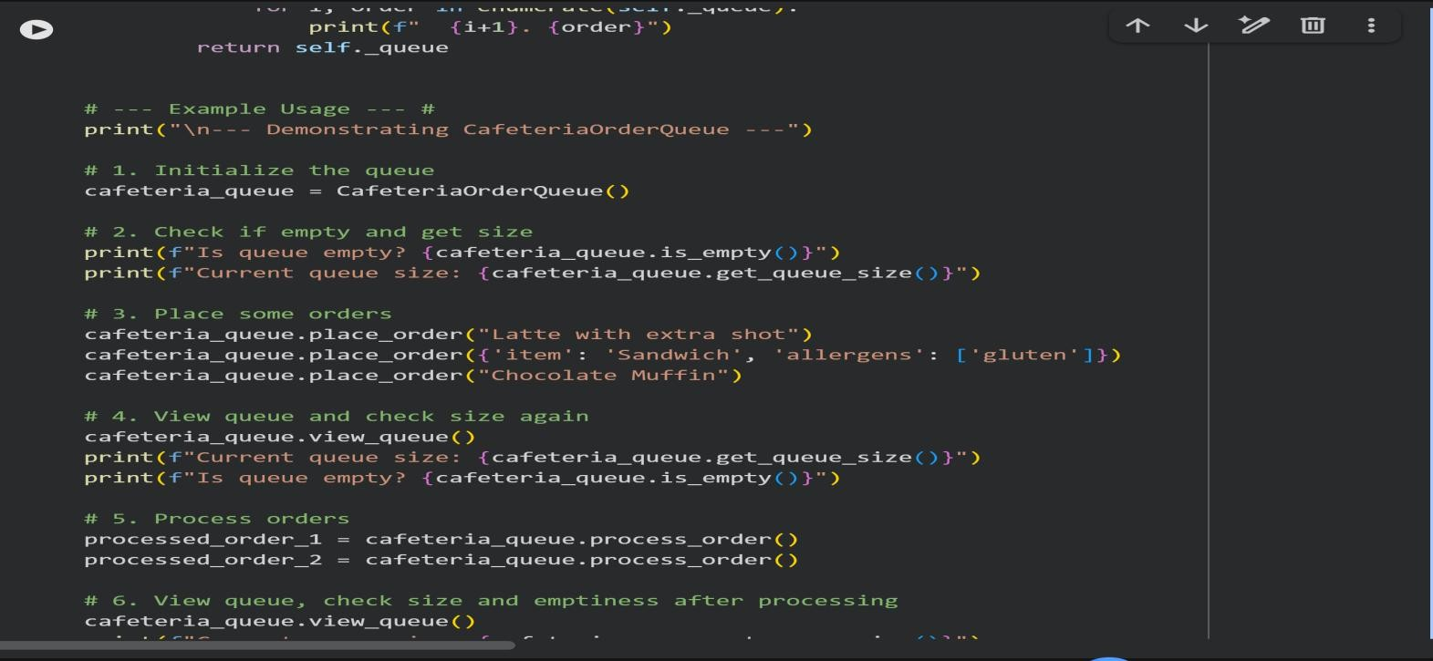
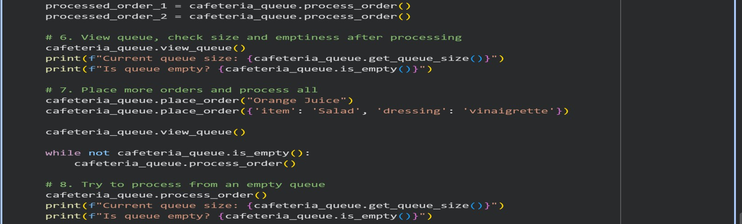

FinalTask Subtask:
Providethegeneratedtableoffeatures,chosendatastructures,andjustifications,along with the Python program for the Cafeteria Order Queue implementation.
Summary:
DataAnalysisKeyFindings
    - StudentAttendanceTracking:AHashTablewasselectedasthemostappropriate data structuredue to itsaverage O(1) time complexity for adding,removing, and looking up student records by ID, ensuring quick real-time access.
    - Event Registration System: A Hash Table was chosen for efficiently managing registeredparticipantswithquicklookups,whileaQueuewasrecommendedfor handling waiting lists on a first-come, first-served basis.
    - LibraryBookBorrowing:AHashTablewasidentifiedassuitablefortrackingbooks and borrowers, enabling fast searches by ISBN or user ID.
    - BusSchedulingSystem:AGraphwasdeemedmostappropriateforthissystem,asit effectively represents routes as edges and stops as nodes, supporting complex
operationslikeoptimalpathfinding.
    - CafeteriaOrderQueue:AQueuewaschosentomodelafirst-come,first-served (FIFO) order processing system, ensuring fair and accurate handling of orders.
    - Data Structure Table Generation: A markdown table was successfully created and populated,clearlymappingeachfeaturetoitschosendatastructureandprovidinga concise justification for each selection.
    - CafeteriaOrderQueueImplementation:APythonclass,CafeteriaOrderQueue,was successfully implemented using a Python list to simulate a FIFO queue. It includes
methodsforplacingorders,processingorders,checkingifthequeueisempty,getting the queue size, and viewing the queue's contents. The implementation correctly demonstrated FIFO behavior and handled edge cases like processing from an empty queue.
InsightsorNext Steps
    - Theexercisesuccessfullydemonstratedhowdifferentdatastructuresareuniquely suited for specific real-time application requirements, prioritizing efficiency and
logicalorder(e.g.,O(1)averagelookupforHashTables,FIFOforQueues).
    - For the CafeteriaOrderQueue implementation, consider enhancing performance by usingPython'scollections.dequemodule,whichoffersmoreefficientappendingand popping from both ends compared to a standard list's pop(0) operation.

askDescription#10:SmartE-CommercePlatform–DataStructure Challenge
Ane-commercecompanywantstobuildaSmartOnlineShoppingSystem with:
- ShoppingCartManagement–Addandremoveproducts dynamically.
- OrderProcessingSystem–Ordersprocessedintheordertheyare placed.
- Top-SellingProductsTracker–Productsrankedbysalescount.
- ProductSearchEngine–Fastlookupofproductsusingproduct ID.
- DeliveryRoutePlanning–Connectwarehousesanddelivery locations.
StudentTask:
  - Foreachfeature,selectthemostappropriatedatastructurefrom the list below:
- Stack
- Queue
- PriorityQueue
- LinkedList
- BinarySearchTree(BST)
- Graph
- Hash Table
- Deque
  - Justifyyourchoicein2–3sentencesper feature.
  - ImplementoneselectedfeatureasaworkingPythonprogramwith AI-assisted code generation.
ExpectedOutput:
  - Atablemappingfeature→chosendatastructure→justification.
  - AfunctionalPythonprogramimplementingthechosenfeature

withcommentsanddocstrings

CODE:
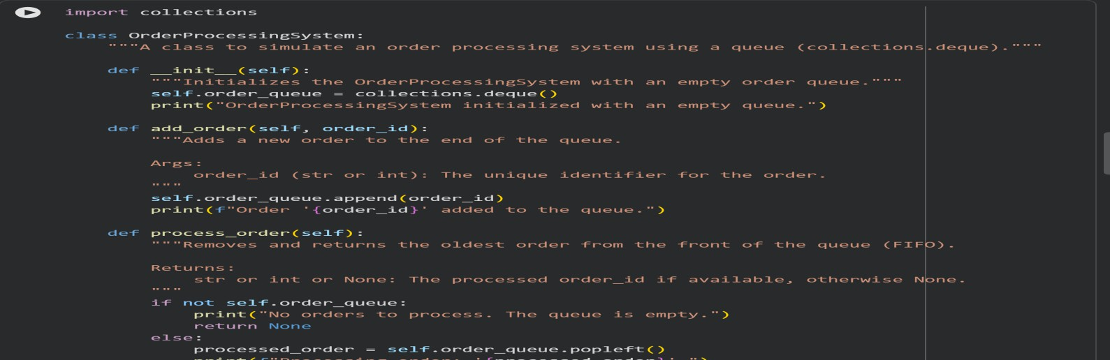
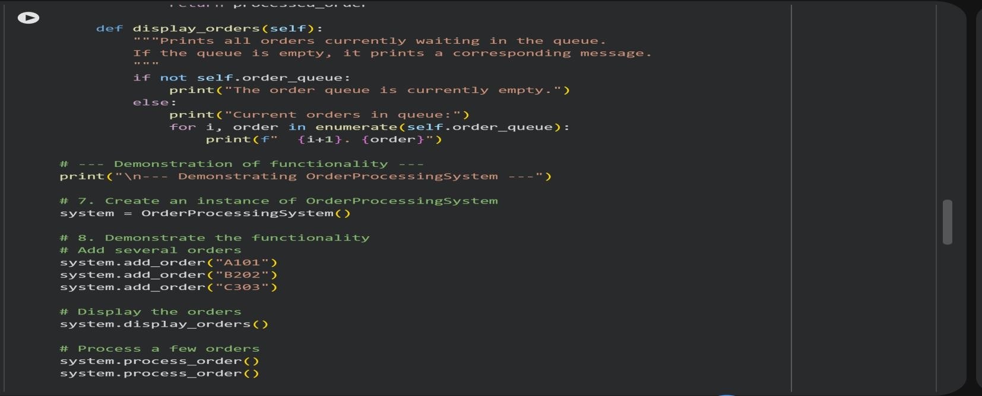
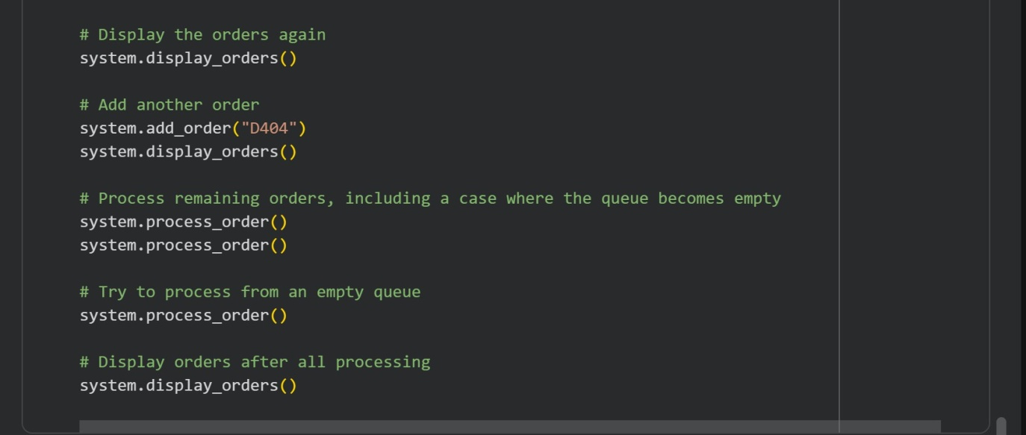

FinalTask Subtask:
Present the table mapping features to chosen data structures with justifications. Also, providetheimplementedPythonprogramfortheOrderProcessingSystem,demonstrating its functionality.

Summary:
DataAnalysisKeyFindings

E-commerceFeaturetoDataStructureMapping:
      - ShoppingCartManagement:BesthandledbyaLinkedListorArrayListfor efficient item insertion/deletion and order maintenance.
      - OrderProcessingSystem:AQueue(FIFOprinciple)isidealforsequential order handling, ensuring fairness.
      - Top-SellingProductsTracker:AMin-Heap(orPriorityQueue)efficiently
storesandupdatesproductsales,allowingquickretrievaloftopNproducts.
      - Product Search Engine: A Trie (Prefix Tree) or Inverted Index optimizes keyword-basedsearchesandautocompletefunctionalitywithfastsearch times.
      - DeliveryRoutePlanning:AGraphnaturallyrepresentslocationsandpaths, enabling algorithms like Dijkstra's for optimal route finding.

OrderProcessingSystemImplementation:
      - A Python OrderProcessingSystem class was successfully implemented usingcollections.dequeastheunderlyingqueueforefficientoperations.
      - Theadd_order,process_order,anddisplay_ordersmethodsfunctioned correctly, adhering to the FIFO principle.
      - Thesystemrobustlyhandledemptyqueuescenariosduringprocessingand display, printing appropriate messages.
      - The demonstration effectively showcased the adding, processing, and displayingoforders,confirmingthesystem'sfunctionalityandadherenceto requirements.
InsightsorNext Steps
    - The chosen data structures align well with the operational requirements of each e- commercefeature,demonstratingastrongunderstandingofdatastructureutilityin real-world applications.

    - The implemented Order Processing System provides a solid foundation; further developmentcouldincludeincorporatingprioritylevelsforurgentorders(usinga priority queue) or persistent storage for orders.

